12576 - Nisanth Saravanan
L1 ASP .NET &MVC Assessmet

Smart Clinic Appointment System

This web application streamlines appointment scheduling for multi-specialty clinics. It enables patients to book appointments based on doctor availability, while doctors and administrators manage schedules and patient records. Built using ASP.NET Core MVC, the system integrates role-based access, calendar management, and automated notifications via background jobs. It enhances operational efficiency and improves patient experience through a responsive and secure interface. Entities: Patient: PatientId, Name, Email, Phone, DOB, Gender
Doctor: DoctorId, Name, Specialization, Availability
Appointment: AppointmentId, PatientId, DoctorId, Date, Time, Status
Notification: NotificationId, UserId, Message, SentDate

Task:

Perform W3H analysis on the given Case Study.
Use the Case Study to implement ASP.Net MVC Core Web application Code-First Approach.
Connect to MySql server and create database and tables as needed and implement table relationships [one to one or one to many or many to many] as required.
Finally, perform all CRUD operations using ASP.MVC Core in the Entity Framework on the given entity. Make the user interactive application with the support of Razor Pages.
- Add data
- Search data by id
- Update data by id
- Delete data by id
- Display all data
W3H Analysis

Project Title: Smart Clinic Appointment System
What? |  | How?
1. What are the various entities needed for this database?  A: Required Entities:  a) Patient  b) Doctor  c) Appointment  2. What are the necessary functionalities of Patient?  A: Patient:  a) Store Patient Data.  b) Edit Patient Data.  c) Delete Patient Data.  3. What are the necessary functionalities of Doctor?  A: Doctor:  a) Store Doctor Data.  b) Edit Doctor Data.  c) Delete Doctor Data.  4. What are the necessary functionalities of Appointment?  A: Appointment:  a) Store Appointment Data.  b) Edit Appointment Data.  c) Delete Appointment Data. |  | 1. Patient:  a) Store Patient Data:  Method 1: Use SQL DB.  Method 2: Use List of Class.  Method 3: Use Local file.  b) Edit Patient Data:  Method 1: Edit by ID.  Method 2: Edit by Name.  Method 3: Edit by range of From to To Date of Creation.  c) Delete Patient Data:  Method 1: Delete by ID.  Method 2: Delete by Name.  Method 3: Delete by range of From to To Date of Creation.  2. Doctor:  a) Store Doctor Data:  Method 1: Use SQL DB.  Method 2: Use List of Class.  Method 3: Use Local file.  b) Edit Doctor Data:  Method 1: Edit by ID.  Method 2: Edit by Name.  Method 3: Edit by range of From to To Date of Creation.  c) Delete Doctor Data:  Method 1: Delete by ID.  Method 2: Delete by Name.  Method 3: Delete by range of From to To Date of Creation.  3. Appointment:  a) Store Appointment Data:  Method 1: Use SQL DB.  Method 2: Use List of Class.  Method 3: Use Local file.  b) Edit Appointment Data:  Method 1: Edit by ID.  Method 2: Edit by Name.  Method 3: Edit by range of From to To Date of Creation.  c) Delete Appointment Data:  Method 1: Delete by ID.  Method 2: Delete by Name.  Method 3: Delete by range of From to To Date of Creation.
1. Patient:  a) Store Patient Data:  Method 1: Use SQL DB.  A: Fits the use case and proves to be a highly effective method to achieve the desired outcome.  b) Edit Patient Data:  Method 1: Edit by ID.  A: Fits the use case and proves to be a highly effective method to achieve the desired outcome.  c) Delete Patient Data:  Method 1: Delete by ID.  A: Fits the use case and proves to be a highly effective method to achieve the desired outcome.  2. Doctor:  a) Store Doctor Data:  Method 1: Use SQL DB.  A: Fits the use case and proves to be a highly effective method to achieve the desired outcome.  b) Edit Doctor Data:  Method 1: Edit by ID.  A: Fits the use case and proves to be a highly effective method to achieve the desired outcome.  c) Delete Doctor Data:  Method 1: Delete by ID.  A: Fits the use case and proves to be a highly effective method to achieve the desired outcome.  3. Appointment:  a) Store Appointment Data:  Method 1: Use SQL DB.  A: Fits the use case and proves to be a highly effective method to achieve the desired outcome.  b) Edit Appointment Data:  Method 1: Edit by ID.  A: Fits the use case and proves to be a highly effective method to achieve the desired outcome.  c) Delete Appointment Data:  Method 1: Delete by ID.  A: Fits the use case and proves to be a highly effective method to achieve the desired outcome. |  | 1. Patient:  a) Store Patient Data:  Method 2: Use List of Class.  Method 3: Use Local file.  A: The methods are feasible, but they lack the effectiveness to be selected as the primary option.  b) Edit Patient Data:  Method 2: Edit by Name.  Method 3: Edit by range of From to To Date of Creation.  A: The methods are feasible, but they lack the effectiveness to be selected as the primary option.  c) Delete Patient Data:  Method 2: Delete by Name.  Method 3: Delete by range of From to To Date of Creation.  A: The methods are feasible, but they lack the effectiveness to be selected as the primary option.  2. Doctor:  a) Store Doctor Data:  Method 2: Use List of Class.  Method 3: Use Local file.  A: The methods are feasible, but they lack the effectiveness to be selected as the primary option.  b) Edit Doctor Data:  Method 2: Edit by Name.  Method 3: Edit by range of From to To Date of Creation.  A: The methods are feasible, but they lack the effectiveness to be selected as the primary option.  c) Delete Doctor Data:  Method 2: Delete by Name.  Method 3: Delete by range of From to To Date of Creation.  A: The methods are feasible, but they lack the effectiveness to be selected as the primary option.  3. Appointment:  a) Store Appointment Data:  Method 2: Use List of Class.  Method 3: Use Local file.  A: The methods are feasible, but they lack the effectiveness to be selected as the primary option.  b) Edit Appointment Data:  Method 2: Edit by Name.  Method 3: Edit by range of From to To Date of Creation.  A: The methods are feasible, but they lack the effectiveness to be selected as the primary option.  c) Delete Appointment Data:  Method 2: Delete by Name.  Method 3: Delete by range of From to To Date of Creation.  A: The methods are feasible, but they lack the effectiveness to be selected as the primary option.
Why? |  | Why Not?

Code
Models

Patient

using System;
using System.Collections.Generic;

namespace AppointmentManager.Models;

public partial class Patient
{
public int PatientId { get; set; }

public string? PatientName { get; set; }

public string? PatientEmail { get; set; }

public int? PatientPhone { get; set; }

public DateOnly? PatientDob { get; set; }

public string? PatientGender { get; set; }

public virtual Appointment? Appointment { get; set; }
}

Doctor

using System;
using System.Collections.Generic;

namespace AppointmentManager.Models;

public partial class Doctor
{
public int DoctorId { get; set; }

public string? DoctorName { get; set; }

public string? Specialization { get; set; }

public string? Availability { get; set; }

public virtual Appointment? Appointment { get; set; }
}

Appointment

using System;
using System.Collections.Generic;

namespace AppointmentManager.Models;

public partial class Appointment
{
public int AppointmentId { get; set; }

public int? PatientId { get; set; }

public int? DoctorId { get; set; }

public DateOnly? DateofAppoint { get; set; }

public TimeOnly? TimeofAppoint { get; set; }

public string? StatusofAppoint { get; set; }

public virtual Doctor? Doctor { get; set; }

public virtual Patient? Patient { get; set; }
}

Controllers

Patient

using System;
using System.Collections.Generic;
using System.Linq;
using System.Threading.Tasks;
using Microsoft.AspNetCore.Mvc;
using Microsoft.AspNetCore.Mvc.Rendering;
using Microsoft.EntityFrameworkCore;
using AppointmentManager.Data;
using AppointmentManager.Models;

namespace AppointmentManager.Controllers
{
public class PatientController : Controller
{
private readonly AppDbContext _context;

public PatientController(AppDbContext context)
{
_context = context;
}

// GET: Patient
public async Task<IActionResult> Index()
{
return View(await _context.Patients.ToListAsync());
}

// GET: Patient/Details/5
public async Task<IActionResult> Details(int? id)
{
if (id == null)
{
return NotFound();
}

var patient = await _context.Patients
.FirstOrDefaultAsync(m => m.PatientId == id);
if (patient == null)
{
return NotFound();
}

return View(patient);
}

// GET: Patient/Create
public IActionResult Create()
{
return View();
}

// POST: Patient/Create
// To protect from overposting attacks, enable the specific properties you want to bind to.
// For more details, see http://go.microsoft.com/fwlink/?LinkId=317598.
[HttpPost]
[ValidateAntiForgeryToken]
public async Task<IActionResult> Create([Bind("PatientId,PatientName,PatientEmail,PatientPhone,PatientDob,PatientGender")] Patient patient)
{
if (ModelState.IsValid)
{

if (patient.PatientGender == "" || patient.PatientGender == null) {
return RedirectToAction(nameof(Create));
}

_context.Add(patient);
await _context.SaveChangesAsync();
return RedirectToAction(nameof(Index));
}
return View(patient);
}

// GET: Patient/Edit/5
public async Task<IActionResult> Edit(int? id)
{
if (id == null)
{
return NotFound();
}

var patient = await _context.Patients.FindAsync(id);
if (patient == null)
{
return NotFound();
}
return View(patient);
}

// POST: Patient/Edit/5
// To protect from overposting attacks, enable the specific properties you want to bind to.
// For more details, see http://go.microsoft.com/fwlink/?LinkId=317598.
[HttpPost]
[ValidateAntiForgeryToken]
public async Task<IActionResult> Edit(int id, [Bind("PatientId,PatientName,PatientEmail,PatientPhone,PatientDob,PatientGender")] Patient patient)
{
if (id != patient.PatientId)
{
return NotFound();
}

if (ModelState.IsValid)
{
try
{

if (patient.PatientGender == "" || patient.PatientGender == null)
{
return RedirectToAction(nameof(Edit));
}

_context.Update(patient);
await _context.SaveChangesAsync();
}
catch (DbUpdateConcurrencyException)
{
if (!PatientExists(patient.PatientId))
{
return NotFound();
}
else
{
throw;
}
}
return RedirectToAction(nameof(Index));
}
return View(patient);
}

// GET: Patient/Delete/5
public async Task<IActionResult> Delete(int? id)
{
if (id == null)
{
return NotFound();
}

var patient = await _context.Patients
.FirstOrDefaultAsync(m => m.PatientId == id);
if (patient == null)
{
return NotFound();
}

return View(patient);
}

// POST: Patient/Delete/5
[HttpPost, ActionName("Delete")]
[ValidateAntiForgeryToken]
public async Task<IActionResult> DeleteConfirmed(int id)
{
var patient = await _context.Patients.FindAsync(id);
if (patient != null)
{
_context.Patients.Remove(patient);
}

await _context.SaveChangesAsync();
return RedirectToAction(nameof(Index));
}

private bool PatientExists(int id)
{
return _context.Patients.Any(e => e.PatientId == id);
}
}
}

Doctor

using System;
using System.Collections.Generic;
using System.Linq;
using System.Threading.Tasks;
using Microsoft.AspNetCore.Mvc;
using Microsoft.AspNetCore.Mvc.Rendering;
using Microsoft.EntityFrameworkCore;
using AppointmentManager.Data;
using AppointmentManager.Models;

namespace AppointmentManager.Controllers
{
public class DoctorController : Controller
{
private readonly AppDbContext _context;

public DoctorController(AppDbContext context)
{
_context = context;
}

// GET: Doctor
public async Task<IActionResult> Index()
{
return View(await _context.Doctors.ToListAsync());
}

// GET: Doctor/Details/5
public async Task<IActionResult> Details(int? id)
{
if (id == null)
{
return NotFound();
}

var doctor = await _context.Doctors
.FirstOrDefaultAsync(m => m.DoctorId == id);
if (doctor == null)
{
return NotFound();
}

return View(doctor);
}

// GET: Doctor/Create
public IActionResult Create()
{
return View();
}

// POST: Doctor/Create
// To protect from overposting attacks, enable the specific properties you want to bind to.
// For more details, see http://go.microsoft.com/fwlink/?LinkId=317598.
[HttpPost]
[ValidateAntiForgeryToken]
public async Task<IActionResult> Create([Bind("DoctorId,DoctorName,Specialization,Availability")] Doctor doctor)
{
if (ModelState.IsValid)
{

if(doctor.Availability == "" || doctor.Availability == null)
{
return RedirectToAction(nameof(Create));
}

_context.Add(doctor);
await _context.SaveChangesAsync();
return RedirectToAction(nameof(Index));
}
return View(doctor);
}

// GET: Doctor/Edit/5
public async Task<IActionResult> Edit(int? id)
{
if (id == null)
{
return NotFound();
}

var doctor = await _context.Doctors.FindAsync(id);
if (doctor == null)
{
return NotFound();
}
return View(doctor);
}

// POST: Doctor/Edit/5
// To protect from overposting attacks, enable the specific properties you want to bind to.
// For more details, see http://go.microsoft.com/fwlink/?LinkId=317598.
[HttpPost]
[ValidateAntiForgeryToken]
public async Task<IActionResult> Edit(int id, [Bind("DoctorId,DoctorName,Specialization,Availability")] Doctor doctor)
{
if (id != doctor.DoctorId)
{
return NotFound();
}

if (ModelState.IsValid)
{
try
{

if (doctor.Availability == "" || doctor.Availability == null)
{
return RedirectToAction(nameof(Edit));
}

_context.Update(doctor);
await _context.SaveChangesAsync();
}
catch (DbUpdateConcurrencyException)
{
if (!DoctorExists(doctor.DoctorId))
{
return NotFound();
}
else
{
throw;
}
}
return RedirectToAction(nameof(Index));
}
return View(doctor);
}

// GET: Doctor/Delete/5
public async Task<IActionResult> Delete(int? id)
{
if (id == null)
{
return NotFound();
}

var doctor = await _context.Doctors
.FirstOrDefaultAsync(m => m.DoctorId == id);
if (doctor == null)
{
return NotFound();
}

return View(doctor);
}

// POST: Doctor/Delete/5
[HttpPost, ActionName("Delete")]
[ValidateAntiForgeryToken]
public async Task<IActionResult> DeleteConfirmed(int id)
{
var doctor = await _context.Doctors.FindAsync(id);
if (doctor != null)
{
_context.Doctors.Remove(doctor);
}

await _context.SaveChangesAsync();
return RedirectToAction(nameof(Index));
}

private bool DoctorExists(int id)
{
return _context.Doctors.Any(e => e.DoctorId == id);
}
}
}

Appointment

using System;
using System.Collections.Generic;
using System.Linq;
using System.Threading.Tasks;
using Microsoft.AspNetCore.Mvc;
using Microsoft.AspNetCore.Mvc.Rendering;
using Microsoft.EntityFrameworkCore;
using AppointmentManager.Data;
using AppointmentManager.Models;

namespace AppointmentManager.Controllers
{
public class AppointmentController : Controller
{
private readonly AppDbContext _context;

public AppointmentController(AppDbContext context)
{
_context = context;
}

// GET: Appointment
public async Task<IActionResult> Index()
{
var appDbContext = _context.Appointments.Include(a => a.Doctor).Include(a => a.Patient);
return View(await appDbContext.ToListAsync());
}

// GET: Appointment/Details/5
public async Task<IActionResult> Details(int? id)
{
if (id == null)
{
return NotFound();
}

var appointment = await _context.Appointments
.Include(a => a.Doctor)
.Include(a => a.Patient)
.FirstOrDefaultAsync(m => m.AppointmentId == id);
if (appointment == null)
{
return NotFound();
}

return View(appointment);
}

// GET: Appointment/Create
public IActionResult Create()
{
ViewData["DoctorId"] = new SelectList(_context.Doctors, "DoctorId", "DoctorId");
ViewData["PatientId"] = new SelectList(_context.Patients, "PatientId", "PatientId");
ViewData["DoctorName"] = new SelectList(_context.Doctors, "DoctorId", "DoctorName");
ViewData["PatientName"] = new SelectList(_context.Patients, "PatientId", "PatientName");
return View();
}

// POST: Appointment/Create
// To protect from overposting attacks, enable the specific properties you want to bind to.
// For more details, see http://go.microsoft.com/fwlink/?LinkId=317598.
[HttpPost]
[ValidateAntiForgeryToken]
public async Task<IActionResult> Create([Bind("AppointmentId,PatientId,DoctorId,DateofAppoint,TimeofAppoint,StatusofAppoint")] Appointment appointment)
{
if (ModelState.IsValid)
{

if(appointment.StatusofAppoint == "" || appointment.StatusofAppoint == null)
{
return RedirectToAction(nameof(Create));
}

_context.Add(appointment);
await _context.SaveChangesAsync();
return RedirectToAction(nameof(Index));
}
ViewData["DoctorId"] = new SelectList(_context.Doctors, "DoctorId", "DoctorId", appointment.DoctorId);
ViewData["PatientId"] = new SelectList(_context.Patients, "PatientId", "PatientId", appointment.PatientId);
return View(appointment);
}

// GET: Appointment/Edit/5
public async Task<IActionResult> Edit(int? id)
{
if (id == null)
{
return NotFound();
}

var appointment = await _context.Appointments.FindAsync(id);
if (appointment == null)
{
return NotFound();
}
ViewData["DoctorName"] = new SelectList(_context.Doctors, "DoctorId", "DoctorName");
ViewData["PatientName"] = new SelectList(_context.Patients, "PatientId", "PatientName");
ViewData["DoctorId"] = new SelectList(_context.Doctors, "DoctorId", "DoctorId", appointment.DoctorId);
ViewData["PatientId"] = new SelectList(_context.Patients, "PatientId", "PatientId", appointment.PatientId);
return View(appointment);
}

// POST: Appointment/Edit/5
// To protect from overposting attacks, enable the specific properties you want to bind to.
// For more details, see http://go.microsoft.com/fwlink/?LinkId=317598.
[HttpPost]
[ValidateAntiForgeryToken]
public async Task<IActionResult> Edit(int id, [Bind("AppointmentId,PatientId,DoctorId,DateofAppoint,TimeofAppoint,StatusofAppoint")] Appointment appointment)
{
if (id != appointment.AppointmentId)
{
return NotFound();
}

if (ModelState.IsValid)
{
try
{

if (appointment.StatusofAppoint == "" || appointment.StatusofAppoint == null)
{
return RedirectToAction(nameof(Edit));
}

_context.Update(appointment);
await _context.SaveChangesAsync();
}
catch (DbUpdateConcurrencyException)
{
if (!AppointmentExists(appointment.AppointmentId))
{
return NotFound();
}
else
{
throw;
}
}
return RedirectToAction(nameof(Index));
}
ViewData["DoctorId"] = new SelectList(_context.Doctors, "DoctorId", "DoctorId", appointment.DoctorId);
ViewData["PatientId"] = new SelectList(_context.Patients, "PatientId", "PatientId", appointment.PatientId);
return View(appointment);
}

// GET: Appointment/Delete/5
public async Task<IActionResult> Delete(int? id)
{
if (id == null)
{
return NotFound();
}

var appointment = await _context.Appointments
.Include(a => a.Doctor)
.Include(a => a.Patient)
.FirstOrDefaultAsync(m => m.AppointmentId == id);
if (appointment == null)
{
return NotFound();
}

return View(appointment);
}

// POST: Appointment/Delete/5
[HttpPost, ActionName("Delete")]
[ValidateAntiForgeryToken]
public async Task<IActionResult> DeleteConfirmed(int id)
{
var appointment = await _context.Appointments.FindAsync(id);
if (appointment != null)
{
_context.Appointments.Remove(appointment);
}

await _context.SaveChangesAsync();
return RedirectToAction(nameof(Index));
}

private bool AppointmentExists(int id)
{
return _context.Appointments.Any(e => e.AppointmentId == id);
}
}
}

DbContext

using System;
using System.Collections.Generic;
using AppointmentManager.Models;
using Microsoft.EntityFrameworkCore;

namespace AppointmentManager.Data;

public partial class AppDbContext : DbContext
{
public AppDbContext()
{
}

public AppDbContext(DbContextOptions<AppDbContext> options)
: base(options)
{
}

public virtual DbSet<Appointment> Appointments { get; set; }

public virtual DbSet<Doctor> Doctors { get; set; }

public virtual DbSet<Patient> Patients { get; set; }
}
Views

Home/Index

@{
ViewData["Title"] = "Home Page";
}

<div class="text-center">
<h1 class="display-4">Welcome To Rz Hozpitalz!</h1>
<p>Lorem ipsum dolor sit amet, consectetur adipiscing elit, sed do eiusmod tempor incididunt ut labore et dolore magna aliqua.
Ut enim ad minim veniam, quis nostrud exercitation ullamco laboris nisi ut aliquip ex ea commodo consequat.
Duis aute irure dolor in reprehenderit in voluptate velit esse cillum dolore eu fugiat nulla pariatur.
Excepteur sint occaecat cupidatat non proident, sunt in culpa qui officia deserunt mollit anim id est laborum.</p>
<br />
<br />
<button class="btn btn-dark"><a class="text-decoration-none text-light" asp-area="" asp-controller="Doctor" asp-action="Index">View Doctors</a></button>
<button class="btn btn-dark"><a class="text-decoration-none text-light" asp-area="" asp-controller="Appointment" asp-action="Index">View Appointments</a></button>
<button class="btn btn-dark"><a class="text-decoration-none text-light" asp-area="" asp-controller="Patient" asp-action="Index">View Patients</a></button>
</div>

Patient/Index

@model IEnumerable<AppointmentManager.Models.Patient>

@{
ViewData["Title"] = "Index";
}

<h1>Index</h1>

<p>
<button class="btn btn-dark"><a class="text-decoration-none text-light" asp-action="Create">Create New Record</a></button>
</p>
<table class="table">
<thead>
<tr>
<th>
@Html.DisplayNameFor(model => model.PatientName)
</th>
<th>
@Html.DisplayNameFor(model => model.PatientEmail)
</th>
<th>
@Html.DisplayNameFor(model => model.PatientPhone)
</th>
<th>
@Html.DisplayNameFor(model => model.PatientDob)
</th>
<th>
@Html.DisplayNameFor(model => model.PatientGender)
</th>
<th></th>
</tr>
</thead>
<tbody>
@foreach (var item in Model) {
<tr>
<td>
@Html.DisplayFor(modelItem => item.PatientName)
</td>
<td>
@Html.DisplayFor(modelItem => item.PatientEmail)
</td>
<td>
@Html.DisplayFor(modelItem => item.PatientPhone)
</td>
<td>
@Html.DisplayFor(modelItem => item.PatientDob)
</td>
<td>
@Html.DisplayFor(modelItem => item.PatientGender)
</td>
<td>
<button class="btn btn-primary"><a class ="text-decoration-none text-light" asp-action="Edit" asp-route-id="@item.PatientId">Edit</a></button> |
<button class="btn btn-info"><a class="text-decoration-none text-light" asp-action="Details" asp-route-id="@item.PatientId">Details</a></button> |
<button class="btn btn-danger"><a class="text-decoration-none text-light" asp-action="Delete" asp-route-id="@item.PatientId">Delete</a></button>
</td>
</tr>
}
</tbody>
</table>
Patient/Create

@model AppointmentManager.Models.Patient

@{
ViewData["Title"] = "Create";
}

<h1>Create</h1>

<h4>Patient</h4>
<hr />
<div class="row">
<div class="col-md-4">
<form asp-action="Create">
<div asp-validation-summary="ModelOnly" class="text-danger"></div>
<div class="form-group">
<label asp-for="PatientName" class="control-label">Patient Name:</label>
<input asp-for="PatientName" class="form-control" />
<span asp-validation-for="PatientName" class="text-danger"></span>
</div>
<div class="form-group">
<label asp-for="PatientEmail" class="control-label">Email:</label>
<input asp-for="PatientEmail" class="form-control" />
<span asp-validation-for="PatientEmail" class="text-danger"></span>
</div>
<div class="form-group">
<label asp-for="PatientPhone" class="control-label">Contact Number:</label>
<input asp-for="PatientPhone" class="form-control" />
<span asp-validation-for="PatientPhone" class="text-danger"></span>
</div>
<div class="form-group">
<label asp-for="PatientDob" class="control-label">Date of Birth: (YYYY-MM-DD Format)</label>
<input asp-for="PatientDob" class="form-control" />
<span asp-validation-for="PatientDob" class="text-danger"></span>
</div>
<div class="form-group">
<label asp-for="PatientGender" class="control-label">Gender:</label>
<select asp-for="PatientGender" class="form-control">
<option value="">-- Select Gender --</option>
<option value="Male">Male</option>
<option value="Female">Female</option>
<option value="Other">Other</option>
</select>
<span asp-validation-for="PatientGender" class="text-danger"></span>
</div>
<div class="form-group">
<input type="submit" value="Create" class="btn btn-primary" />
</div>
</form>
</div>
</div>

<div>
<a asp-action="Index">Back to List</a>
</div>

@section Scripts {
@{await Html.RenderPartialAsync("_ValidationScriptsPartial");}
}
Patient/Edit

@model AppointmentManager.Models.Patient

@{
ViewData["Title"] = "Edit";
}

<h1>Edit</h1>

<h4>Patient</h4>
<hr />
<div class="row">
<div class="col-md-4">
<form asp-action="Edit">
<div asp-validation-summary="ModelOnly" class="text-danger"></div>
<input type="hidden" asp-for="PatientId" />
<div class="form-group">
<label asp-for="PatientName" class="control-label">Patient Name:</label>
<input asp-for="PatientName" class="form-control" />
<span asp-validation-for="PatientName" class="text-danger"></span>
</div>
<div class="form-group">
<label asp-for="PatientEmail" class="control-label">Email:</label>
<input asp-for="PatientEmail" class="form-control" />
<span asp-validation-for="PatientEmail" class="text-danger"></span>
</div>
<div class="form-group">
<label asp-for="PatientPhone" class="control-label">Contact Number:</label>
<input asp-for="PatientPhone" class="form-control" />
<span asp-validation-for="PatientPhone" class="text-danger"></span>
</div>
<div class="form-group">
<label asp-for="PatientDob" class="control-label">Date of Birth: (YYYY-MM-DD Format)</label>
<input asp-for="PatientDob" class="form-control" />
<span asp-validation-for="PatientDob" class="text-danger"></span>
</div>
<div class="form-group">
<label asp-for="PatientGender" class="control-label">Gender:</label>
<select asp-for="PatientGender" class="form-control">
<option value="">-- Select Gender --</option>
<option value="Male">Male</option>
<option value="Female">Female</option>
<option value="Other">Other</option>
</select>
<span asp-validation-for="PatientGender" class="text-danger"></span>
</div>
<div class="form-group">
<input type="submit" value="Save" class="btn btn-primary" />
</div>
</form>
</div>
</div>

<div>
<a asp-action="Index">Back to List</a>
</div>

@section Scripts {
@{await Html.RenderPartialAsync("_ValidationScriptsPartial");}
}
Patient/Delete

@model AppointmentManager.Models.Patient

@{
ViewData["Title"] = "Delete";
}

<h1>Delete</h1>

<h3>Are you sure you want to delete this?</h3>
<div>
<h4>Patient</h4>
<hr />
<dl class="row">
<dt class = "col-sm-2">
@Html.DisplayNameFor(model => model.PatientName)
</dt>
<dd class = "col-sm-10">
@Html.DisplayFor(model => model.PatientName)
</dd>
<dt class = "col-sm-2">
@Html.DisplayNameFor(model => model.PatientEmail)
</dt>
<dd class = "col-sm-10">
@Html.DisplayFor(model => model.PatientEmail)
</dd>
<dt class = "col-sm-2">
@Html.DisplayNameFor(model => model.PatientPhone)
</dt>
<dd class = "col-sm-10">
@Html.DisplayFor(model => model.PatientPhone)
</dd>
<dt class = "col-sm-2">
@Html.DisplayNameFor(model => model.PatientDob)
</dt>
<dd class = "col-sm-10">
@Html.DisplayFor(model => model.PatientDob)
</dd>
<dt class = "col-sm-2">
@Html.DisplayNameFor(model => model.PatientGender)
</dt>
<dd class = "col-sm-10">
@Html.DisplayFor(model => model.PatientGender)
</dd>
</dl>

<form asp-action="Delete">
<input type="hidden" asp-for="PatientId" />
<input type="submit" value="Delete" class="btn btn-danger" /> |
<a asp-action="Index">Back to List</a>
</form>
</div>

Patient/Details

@model AppointmentManager.Models.Patient

@{
ViewData["Title"] = "Details";
}

<h1>Details</h1>

<div>
<h4>Patient</h4>
<hr />
<dl class="row">
<dt class = "col-sm-2">
@Html.DisplayNameFor(model => model.PatientName)
</dt>
<dd class = "col-sm-10">
@Html.DisplayFor(model => model.PatientName)
</dd>
<dt class = "col-sm-2">
@Html.DisplayNameFor(model => model.PatientEmail)
</dt>
<dd class = "col-sm-10">
@Html.DisplayFor(model => model.PatientEmail)
</dd>
<dt class = "col-sm-2">
@Html.DisplayNameFor(model => model.PatientPhone)
</dt>
<dd class = "col-sm-10">
@Html.DisplayFor(model => model.PatientPhone)
</dd>
<dt class = "col-sm-2">
@Html.DisplayNameFor(model => model.PatientDob)
</dt>
<dd class = "col-sm-10">
@Html.DisplayFor(model => model.PatientDob)
</dd>
<dt class = "col-sm-2">
@Html.DisplayNameFor(model => model.PatientGender)
</dt>
<dd class = "col-sm-10">
@Html.DisplayFor(model => model.PatientGender)
</dd>
</dl>
</div>
<div>
<a asp-action="Edit" asp-route-id="@Model?.PatientId">Edit</a> |
<a asp-action="Index">Back to List</a>
</div>

Doctor/Index

@model IEnumerable<AppointmentManager.Models.Doctor>

@{
ViewData["Title"] = "Index";
}

<h1>Index</h1>

<p>
<button class="btn btn-dark"><a class="text-decoration-none text-light" asp-action="Create">Create New Record</a></button>
</p>
<table class="table">
<thead>
<tr>
<th>
@Html.DisplayNameFor(model => model.DoctorName)
</th>
<th>
@Html.DisplayNameFor(model => model.Specialization)
</th>
<th>
@Html.DisplayNameFor(model => model.Availability)
</th>
<th></th>
</tr>
</thead>
<tbody>
@foreach (var item in Model) {
<tr>
<td>
@Html.DisplayFor(modelItem => item.DoctorName)
</td>
<td>
@Html.DisplayFor(modelItem => item.Specialization)
</td>
<td>
@Html.DisplayFor(modelItem => item.Availability)
</td>
<td>
<button class="btn btn-primary"><a class="text-decoration-none text-light" asp-action="Edit" asp-route-id="@item.DoctorId">Edit</a></button> |
<button class="btn btn-info"><a class="text-decoration-none text-light" asp-action="Details" asp-route-id="@item.DoctorId">Details</a></button> |
<button class="btn btn-danger"><a class="text-decoration-none text-light" asp-action="Delete" asp-route-id="@item.DoctorId">Delete</a></button>
</td>
</tr>
}
</tbody>
</table>

Doctor/Create

@model AppointmentManager.Models.Doctor

@{
ViewData["Title"] = "Create";
}

<h1>Create</h1>

<h4>Doctor</h4>
<hr />
<div class="row">
<div class="col-md-4">
<form asp-action="Create">
<div asp-validation-summary="ModelOnly" class="text-danger"></div>
<div class="form-group">
<label asp-for="DoctorName" class="control-label">Doctor Name:</label>
<input asp-for="DoctorName" class="form-control" />
<span asp-validation-for="DoctorName" class="text-danger"></span>
</div>
<div class="form-group">
<label asp-for="Specialization" class="control-label">Specialization:</label>
<input asp-for="Specialization" class="form-control" />
<span asp-validation-for="Specialization" class="text-danger"></span>
</div>
<div class="form-group">
<label asp-for="Availability" class="control-label">Availability:</label>
<select asp-for="Availability" class="form-control">
<option value="">-- Select Availability --</option>
<option value="Available">Available</option>
<option value="Unavailable">Unavailable</option>
</select>
<span asp-validation-for="Availability" class="text-danger"></span>
</div>
<div class="form-group">
<input type="submit" value="Create" class="btn btn-primary" />
</div>
</form>
</div>
</div>

<div>
<a asp-action="Index">Back to List</a>
</div>

@section Scripts {
@{await Html.RenderPartialAsync("_ValidationScriptsPartial");}
}

Doctor/Edit

@model AppointmentManager.Models.Doctor

@{
ViewData["Title"] = "Edit";
}

<h1>Edit</h1>

<h4>Doctor</h4>
<hr />
<div class="row">
<div class="col-md-4">
<form asp-action="Edit">
<div asp-validation-summary="ModelOnly" class="text-danger"></div>
<input type="hidden" asp-for="DoctorId" />
<div class="form-group">
<label asp-for="DoctorName" class="control-label">Doctor Name:</label>
<input asp-for="DoctorName" class="form-control" />
<span asp-validation-for="DoctorName" class="text-danger"></span>
</div>
<div class="form-group">
<label asp-for="Specialization" class="control-label">Specialization:</label>
<input asp-for="Specialization" class="form-control" />
<span asp-validation-for="Specialization" class="text-danger"></span>
</div>
<div class="form-group">
<label asp-for="Availability" class="control-label">Availability:</label>
<select asp-for="Availability" class="form-control">
<option value="">-- Select Availability --</option>
<option value="Available">Available</option>
<option value="Unavailable">Unavailable</option>
</select>
<span asp-validation-for="Availability" class="text-danger"></span>
</div>
<div class="form-group">
<input type="submit" value="Save" class="btn btn-primary" />
</div>
</form>
</div>
</div>

<div>
<a asp-action="Index">Back to List</a>
</div>

@section Scripts {
@{await Html.RenderPartialAsync("_ValidationScriptsPartial");}
}

Doctor/Delete

@model AppointmentManager.Models.Doctor

@{
ViewData["Title"] = "Delete";
}

<h1>Delete</h1>

<h3>Are you sure you want to delete this?</h3>
<div>
<h4>Doctor</h4>
<hr />
<dl class="row">
<dt class = "col-sm-2">
@Html.DisplayNameFor(model => model.DoctorName)
</dt>
<dd class = "col-sm-10">
@Html.DisplayFor(model => model.DoctorName)
</dd>
<dt class = "col-sm-2">
@Html.DisplayNameFor(model => model.Specialization)
</dt>
<dd class = "col-sm-10">
@Html.DisplayFor(model => model.Specialization)
</dd>
<dt class = "col-sm-2">
@Html.DisplayNameFor(model => model.Availability)
</dt>
<dd class = "col-sm-10">
@Html.DisplayFor(model => model.Availability)
</dd>
</dl>

<form asp-action="Delete">
<input type="hidden" asp-for="DoctorId" />
<input type="submit" value="Delete" class="btn btn-danger" /> |
<a asp-action="Index">Back to List</a>
</form>
</div>

Doctor/Details

@model AppointmentManager.Models.Doctor

@{
ViewData["Title"] = "Details";
}

<h1>Details</h1>

<div>
<h4>Doctor</h4>
<hr />
<dl class="row">
<dt class = "col-sm-2">
@Html.DisplayNameFor(model => model.DoctorName)
</dt>
<dd class = "col-sm-10">
@Html.DisplayFor(model => model.DoctorName)
</dd>
<dt class = "col-sm-2">
@Html.DisplayNameFor(model => model.Specialization)
</dt>
<dd class = "col-sm-10">
@Html.DisplayFor(model => model.Specialization)
</dd>
<dt class = "col-sm-2">
@Html.DisplayNameFor(model => model.Availability)
</dt>
<dd class = "col-sm-10">
@Html.DisplayFor(model => model.Availability)
</dd>
</dl>
</div>
<div>
<a asp-action="Edit" asp-route-id="@Model?.DoctorId">Edit</a> |
<a asp-action="Index">Back to List</a>
</div>

Appointment/Index

@model IEnumerable<AppointmentManager.Models.Appointment>

@{
ViewData["Title"] = "Index";
}

<h1>Index</h1>

<p>
<button class="btn btn-dark"><a class="text-decoration-none text-light" asp-action="Create">Create New Appointment</a></button>
</p>
<table class="table">
<thead>
<tr>
<th>
@Html.DisplayNameFor(model => model.DateofAppoint)
</th>
<th>
@Html.DisplayNameFor(model => model.TimeofAppoint)
</th>
<th>
@Html.DisplayNameFor(model => model.StatusofAppoint)
</th>
<th>
@Html.DisplayNameFor(model => model.Doctor)
</th>
<th>
@Html.DisplayNameFor(model => model.Patient)
</th>
<th></th>
</tr>
</thead>
<tbody>
@foreach (var item in Model) {
<tr>
<td>
@Html.DisplayFor(modelItem => item.DateofAppoint)
</td>
<td>
@Html.DisplayFor(modelItem => item.TimeofAppoint)
</td>
<td>
@Html.DisplayFor(modelItem => item.StatusofAppoint)
</td>
<td>
@Html.DisplayFor(modelItem => item.Doctor.DoctorName)
</td>
<td>
@Html.DisplayFor(modelItem => item.Patient.PatientName)
</td>
<td>
<button class="btn btn-primary"><a class="text-decoration-none text-light" asp-action="Edit" asp-route-id="@item.AppointmentId">Edit</a></button> |
<button class="btn btn-info"><a class="text-decoration-none text-light" asp-action="Details" asp-route-id="@item.AppointmentId">Details</a></button> |
<button class="btn btn-danger"><a class="text-decoration-none text-light" asp-action="Delete" asp-route-id="@item.AppointmentId">Delete</a></button>
</td>
</tr>
}
</tbody>
</table>
Appointment/Create

@model AppointmentManager.Models.Appointment

@{
ViewData["Title"] = "Create";
}

<h1>Create</h1>

<h4>Appointment</h4>
<hr />
<div class="row">
<div class="col-md-4">
<form asp-action="Create">
<div asp-validation-summary="ModelOnly" class="text-danger"></div>
<div class="form-group">
<label asp-for="PatientId" class="control-label">Patient Name:</label>
<select asp-for="PatientId" class ="form-control" asp-items="ViewBag.PatientName"></select>
</div>
<div class="form-group">
<label asp-for="DoctorId" class="control-label">Doctor Name:</label>
<select asp-for="DoctorId" class ="form-control" asp-items="ViewBag.DoctorName"></select>
</div>
<div class="form-group">
<label asp-for="DateofAppoint" class="control-label">Date of Appointment: (YYYY-MM-DD Format)</label>
<input asp-for="DateofAppoint" class="form-control" />
<span asp-validation-for="DateofAppoint" class="text-danger"></span>
</div>
<div class="form-group">
<label asp-for="TimeofAppoint" class="control-label">Time of Appointment: (24 Hour Format)</label>
<input asp-for="TimeofAppoint" class="form-control" />
<span asp-validation-for="TimeofAppoint" class="text-danger"></span>
</div>
<div class="form-group">
<label asp-for="StatusofAppoint" class="control-label">Status of Appointment:</label>
<select asp-for="StatusofAppoint" class="form-control">
<option value="">-- Select Status --</option>
<option value="Pending">Pending</option>
<option value="Ongoing">Ongoing</option>
<option value="Cancelled">Cancelled</option>
<option value="Completed">Completed</option>
</select>
<span asp-validation-for="StatusofAppoint" class="text-danger"></span>
</div>
<div class="form-group">
<input type="submit" value="Create" class="btn btn-primary" />
</div>
</form>
</div>
</div>

<div>
<a asp-action="Index">Back to List</a>
</div>

@section Scripts {
@{await Html.RenderPartialAsync("_ValidationScriptsPartial");}
}

Appointment/Edit

@model AppointmentManager.Models.Appointment

@{
ViewData["Title"] = "Edit";
}

<h1>Edit</h1>

<h4>Appointment</h4>
<hr />
<div class="row">
<div class="col-md-4">
<form asp-action="Edit">
<div asp-validation-summary="ModelOnly" class="text-danger"></div>
<input type="hidden" asp-for="AppointmentId" />
<div class="form-group">
<label asp-for="PatientId" class="control-label">Patient Name:</label>
<select asp-for="PatientId" class="form-control" asp-items="ViewBag.PatientName"></select>
<span asp-validation-for="PatientId" class="text-danger"></span>
</div>
<div class="form-group">
<label asp-for="DoctorId" class="control-label">Doctor Name:</label>
<select asp-for="DoctorId" class="form-control" asp-items="ViewBag.DoctorName"></select>
<span asp-validation-for="DoctorId" class="text-danger"></span>
</div>
<div class="form-group">
<label asp-for="DateofAppoint" class="control-label">Date of Appointment: (YYYY-MM-DD Format)</label>
<input asp-for="DateofAppoint" class="form-control" />
<span asp-validation-for="DateofAppoint" class="text-danger"></span>
</div>
<div class="form-group">
<label asp-for="TimeofAppoint" class="control-label">Time of Appointment: (24 Hour Format)</label>
<input asp-for="TimeofAppoint" class="form-control" />
<span asp-validation-for="TimeofAppoint" class="text-danger"></span>
</div>
<div class="form-group">
<label asp-for="StatusofAppoint" class="control-label">Status of Appointment:</label>
<select asp-for="StatusofAppoint" class="form-control">
<option value="">-- Select Status --</option>
<option value="Pending">Pending</option>
<option value="Ongoing">Ongoing</option>
<option value="Cancelled">Cancelled</option>
<option value="Completed">Completed</option>
</select>
<span asp-validation-for="StatusofAppoint" class="text-danger"></span>
</div>
<div class="form-group">
<input type="submit" value="Save" class="btn btn-primary" />
</div>
</form>
</div>
</div>

<div>
<a asp-action="Index">Back to List</a>
</div>

@section Scripts {
@{await Html.RenderPartialAsync("_ValidationScriptsPartial");}
}

Appointment/Delete

@model AppointmentManager.Models.Appointment

@{
ViewData["Title"] = "Delete";
}

<h1>Delete</h1>

<h3>Are you sure you want to delete this?</h3>
<div>
<h4>Appointment</h4>
<hr />
<dl class="row">
<dt class = "col-sm-2">
@Html.DisplayNameFor(model => model.DateofAppoint)
</dt>
<dd class = "col-sm-10">
@Html.DisplayFor(model => model.DateofAppoint)
</dd>
<dt class = "col-sm-2">
@Html.DisplayNameFor(model => model.TimeofAppoint)
</dt>
<dd class = "col-sm-10">
@Html.DisplayFor(model => model.TimeofAppoint)
</dd>
<dt class = "col-sm-2">
@Html.DisplayNameFor(model => model.StatusofAppoint)
</dt>
<dd class = "col-sm-10">
@Html.DisplayFor(model => model.StatusofAppoint)
</dd>
<dt class = "col-sm-2">
@Html.DisplayNameFor(model => model.Doctor)
</dt>
<dd class = "col-sm-10">
@Html.DisplayFor(model => model.Doctor.DoctorId)
</dd>
<dt class = "col-sm-2">
@Html.DisplayNameFor(model => model.Patient)
</dt>
<dd class = "col-sm-10">
@Html.DisplayFor(model => model.Patient.PatientId)
</dd>
</dl>

<form asp-action="Delete">
<input type="hidden" asp-for="AppointmentId" />
<input type="submit" value="Delete" class="btn btn-danger" /> |
<a asp-action="Index">Back to List</a>
</form>
</div>

Appointment/Details

@model AppointmentManager.Models.Appointment

@{
ViewData["Title"] = "Details";
}

<h1>Details</h1>

<div>
<h4>Appointment</h4>
<hr />
<dl class="row">
<dt class = "col-sm-2">
@Html.DisplayNameFor(model => model.DateofAppoint)
</dt>
<dd class = "col-sm-10">
@Html.DisplayFor(model => model.DateofAppoint)
</dd>
<dt class = "col-sm-2">
@Html.DisplayNameFor(model => model.TimeofAppoint)
</dt>
<dd class = "col-sm-10">
@Html.DisplayFor(model => model.TimeofAppoint)
</dd>
<dt class = "col-sm-2">
@Html.DisplayNameFor(model => model.StatusofAppoint)
</dt>
<dd class = "col-sm-10">
@Html.DisplayFor(model => model.StatusofAppoint)
</dd>
<dt class = "col-sm-2">
@Html.DisplayNameFor(model => model.Doctor)
</dt>
<dd class = "col-sm-10">
@Html.DisplayFor(model => model.Doctor.DoctorId)
</dd>
<dt class = "col-sm-2">
@Html.DisplayNameFor(model => model.Patient)
</dt>
<dd class = "col-sm-10">
@Html.DisplayFor(model => model.Patient.PatientId)
</dd>
</dl>
</div>
<div>
<a asp-action="Edit" asp-route-id="@Model?.AppointmentId">Edit</a> |
<a asp-action="Index">Back to List</a>
</div>

Program.cs

using AppointmentManager.Data;
using Microsoft.EntityFrameworkCore;
using System;

var builder = WebApplication.CreateBuilder(args);

builder.Services.AddDbContext<AppDbContext>(options => options.UseMySql(builder.Configuration.GetConnectionString("DefaultConnection"),
ServerVersion.AutoDetect((builder.Configuration.GetConnectionString("DefaultConnection")))));

// Add services to the container.
builder.Services.AddControllersWithViews();

var app = builder.Build();

// Configure the HTTP request pipeline.
if (!app.Environment.IsDevelopment())
{
app.UseExceptionHandler("/Home/Error");
// The default HSTS value is 30 days. You may want to change this for production scenarios, see https://aka.ms/aspnetcore-hsts.
app.UseHsts();
}

app.UseHttpsRedirection();
app.UseStaticFiles();

app.UseRouting();

app.UseAuthorization();

app.MapControllerRoute(
name: "default",
pattern: "{controller=Home}/{action=Index}/{id?}");

app.Run();

appsettings.json

{
"Logging": {
"LogLevel": {
"Default": "Information",
"Microsoft.AspNetCore": "Warning"
}
}, //Connection Strings
"ConnectionStrings": {
"DefaultConnection": "server=localhost;user=root;password=root;database=HospitalDb;port=3306;"
},
"AllowedHosts": "*"
}

Output Screens

Home/Index

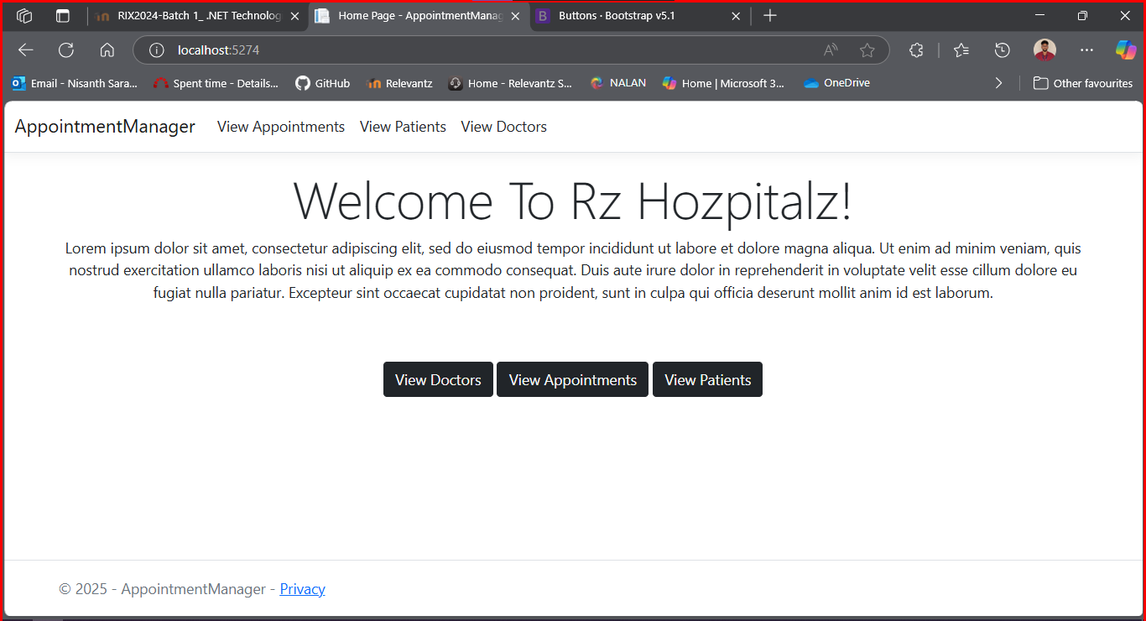

Patient

Create

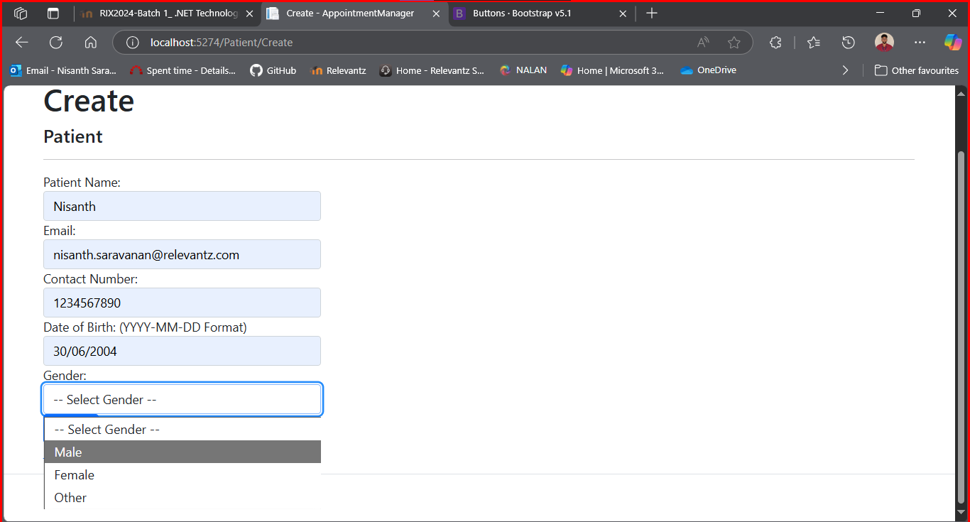

Index

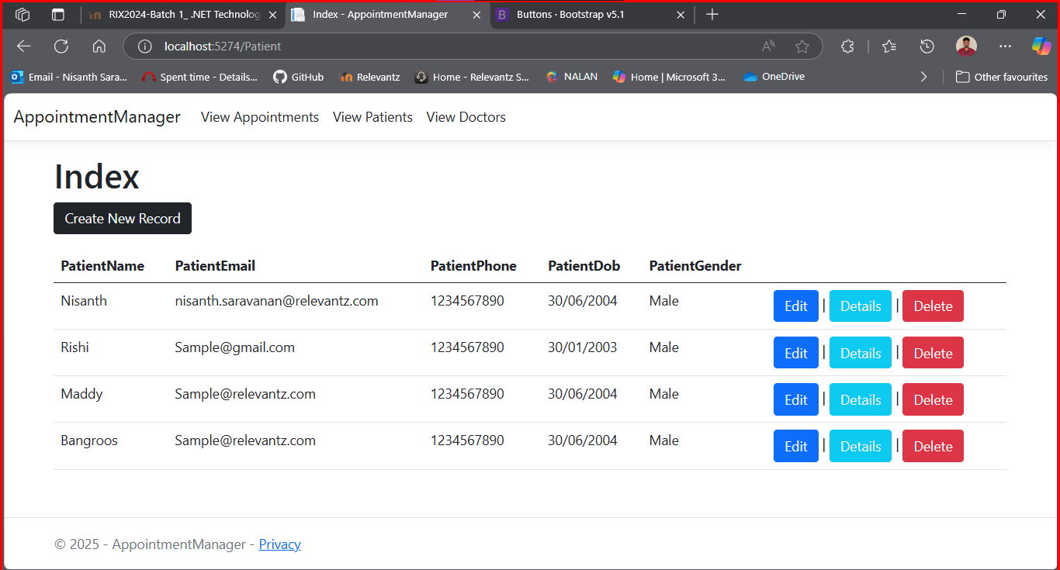
Edit

Before

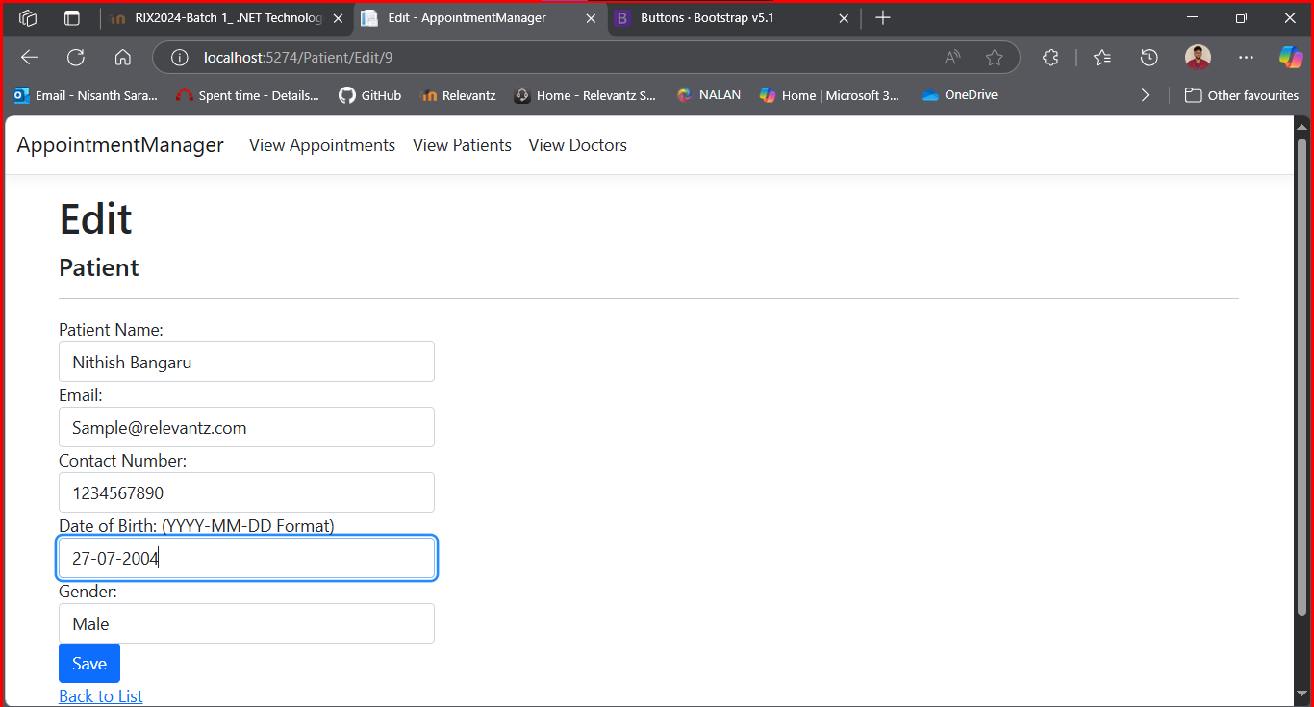

After

Details

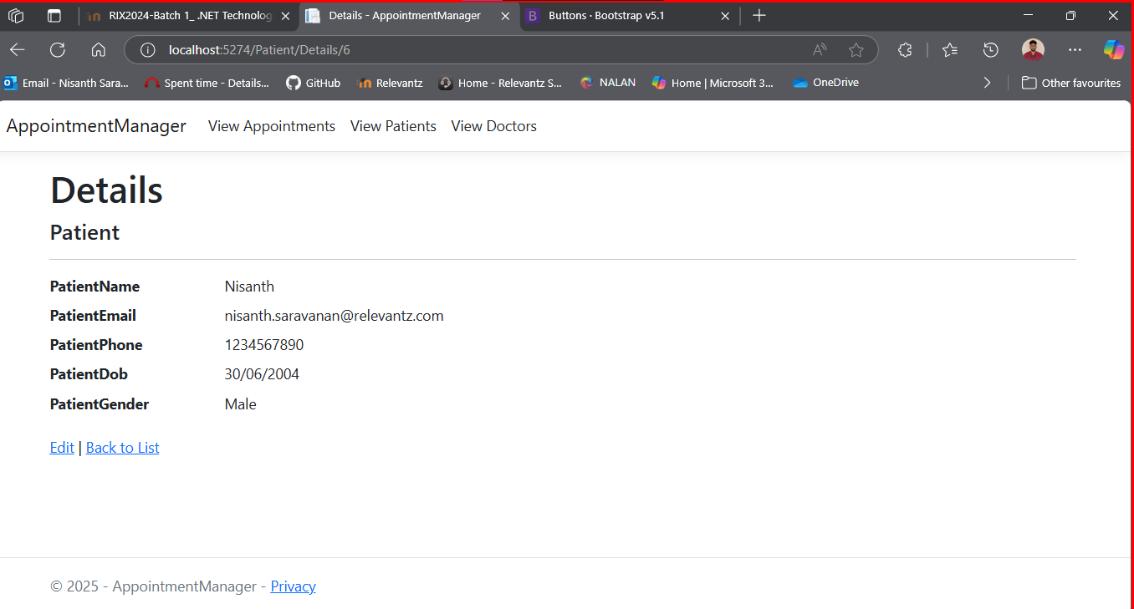

Delete

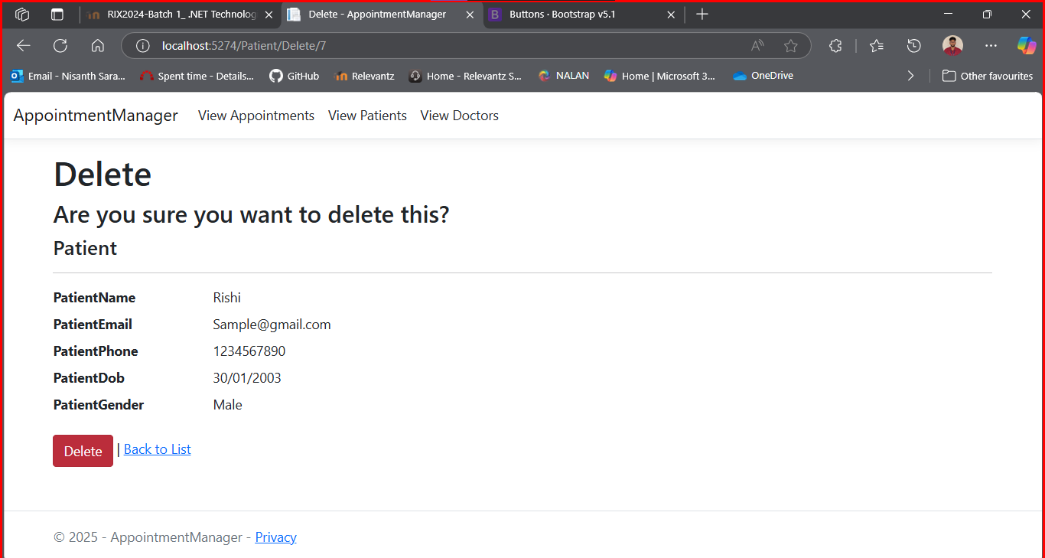

Post Deletion

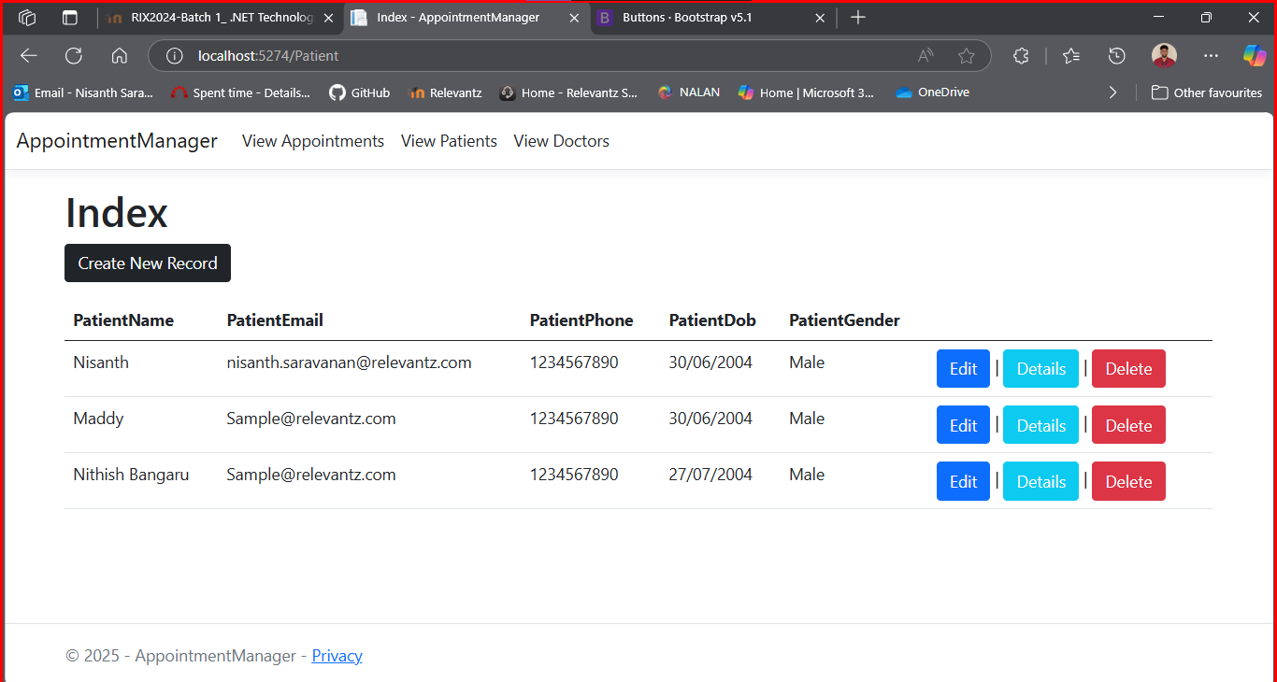

Doctor

Create

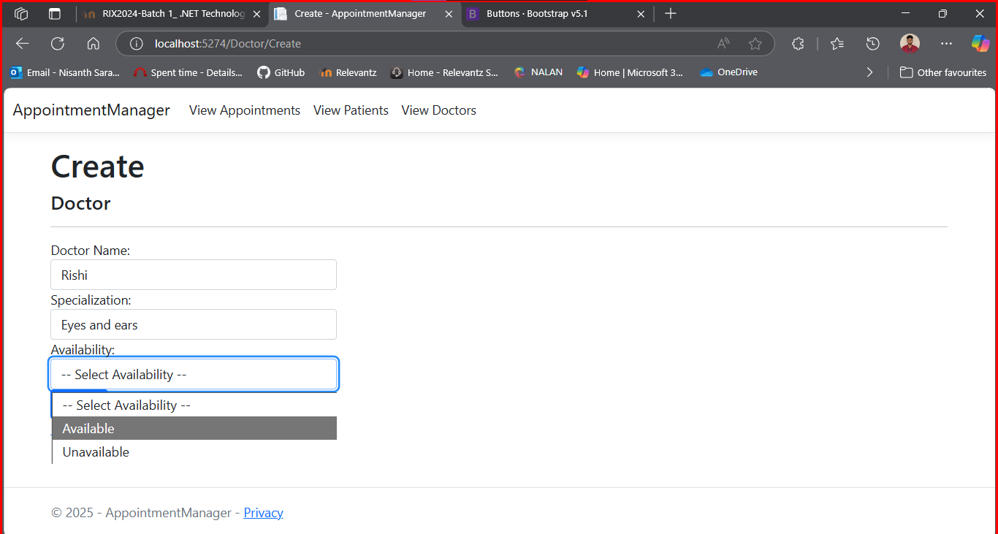

Index

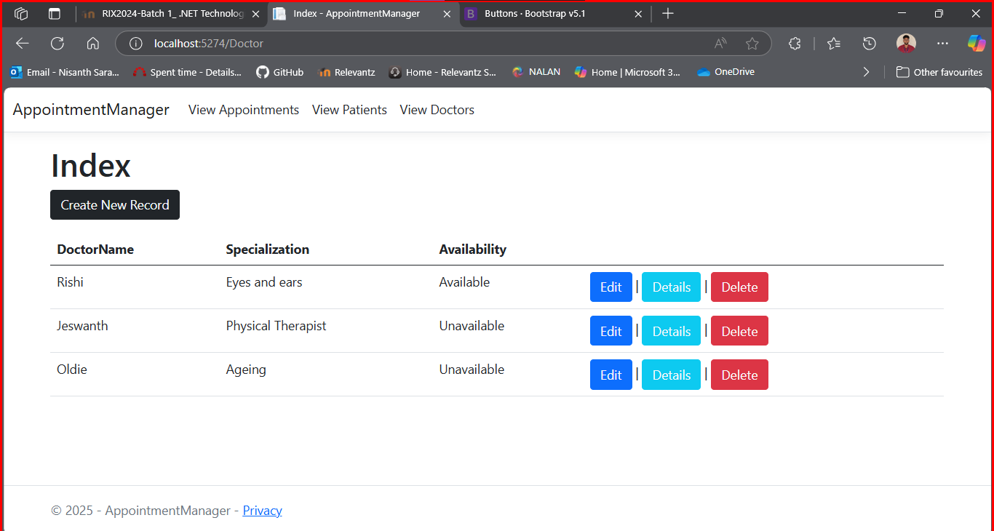
Edit

Before

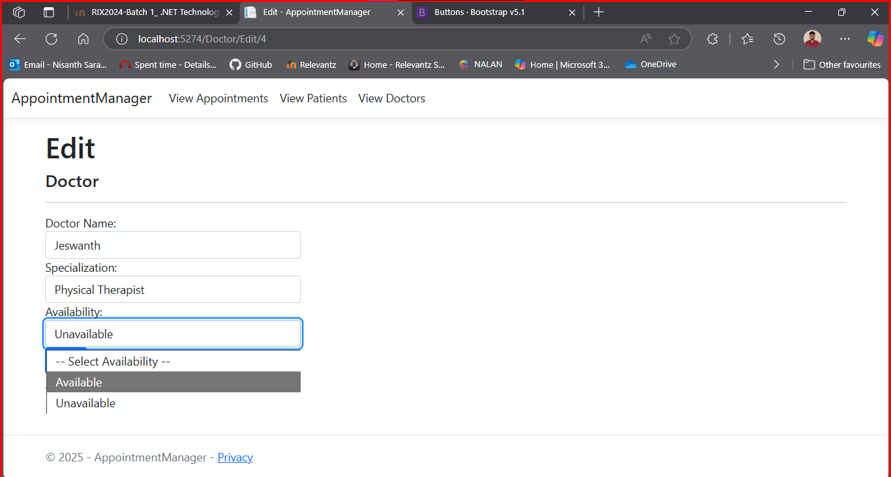

After

Details

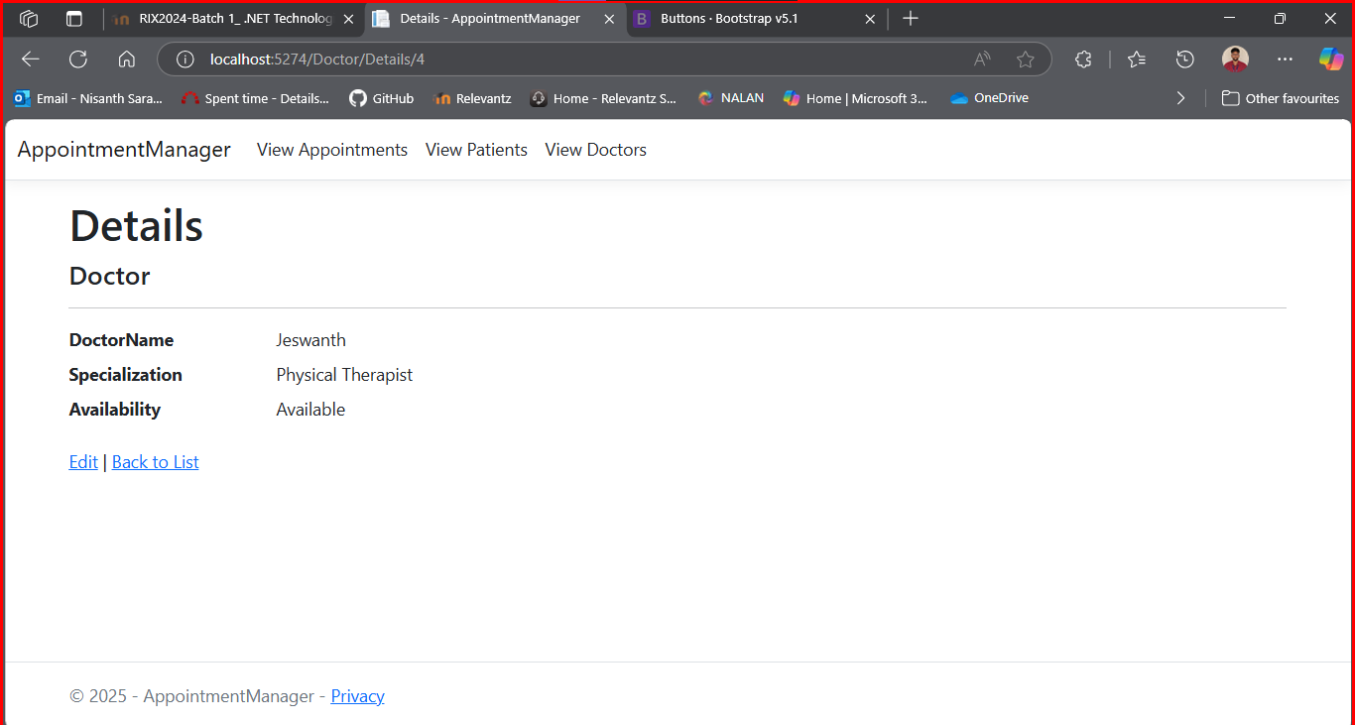

Delete

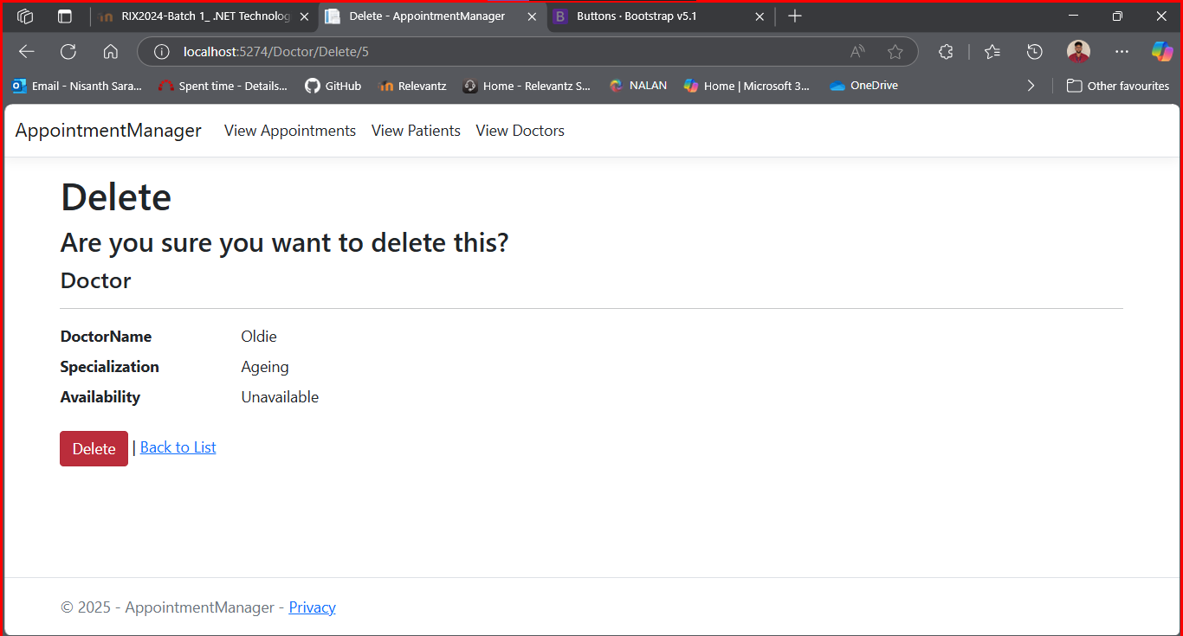

After Deletion

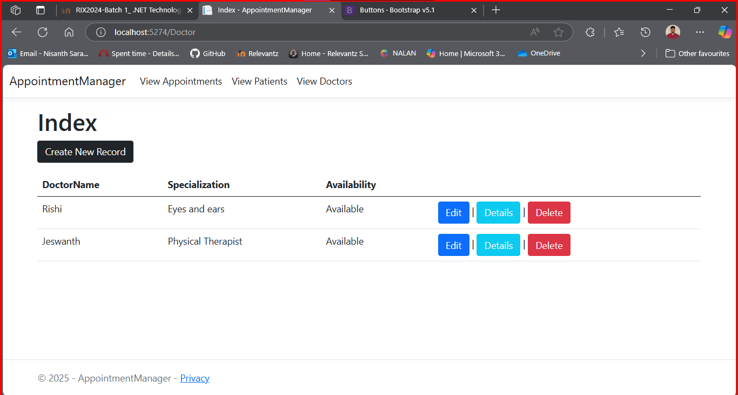
Appointment

Create

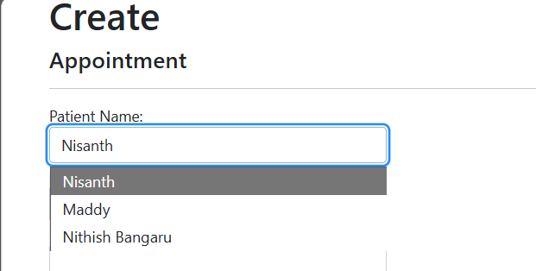

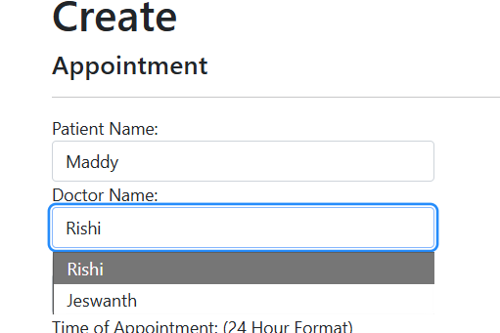
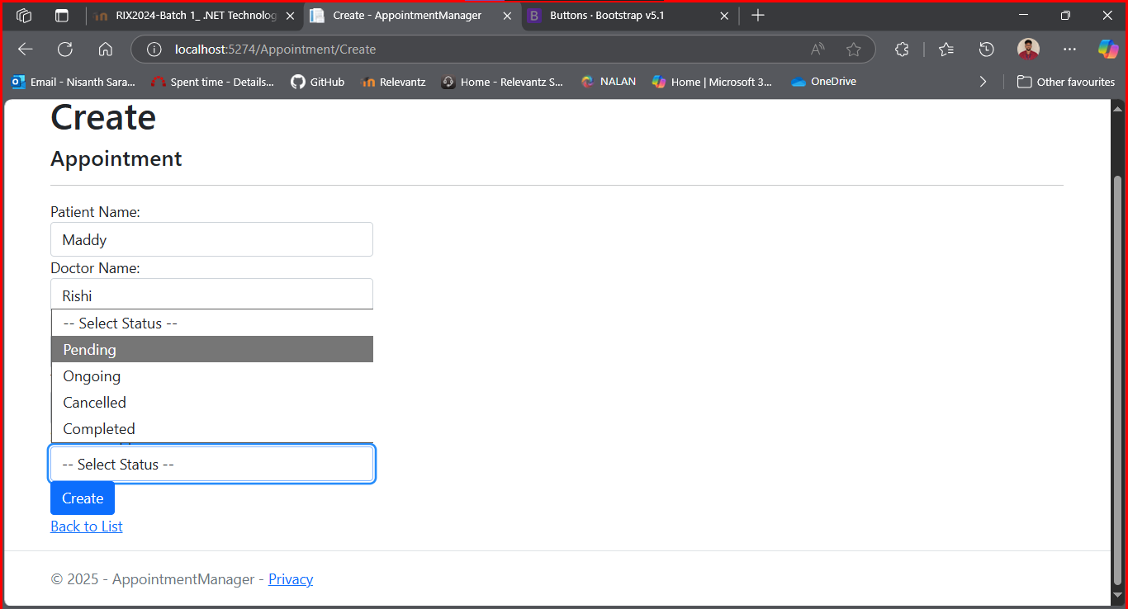

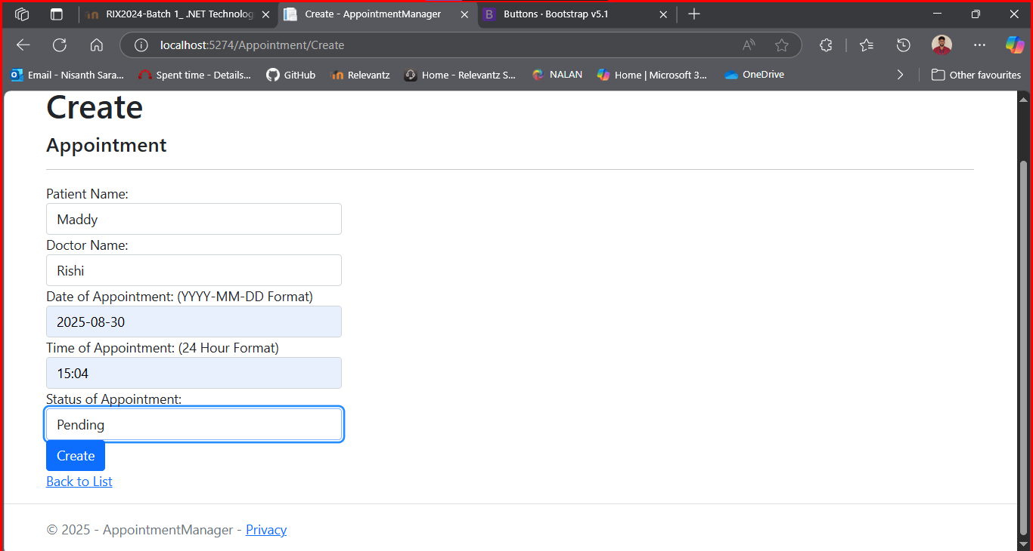

Index

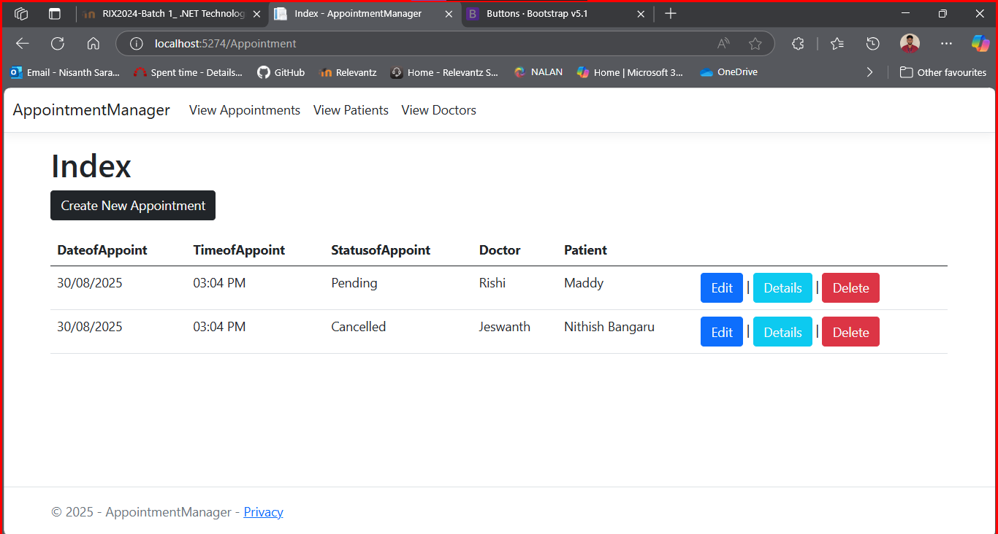

Details

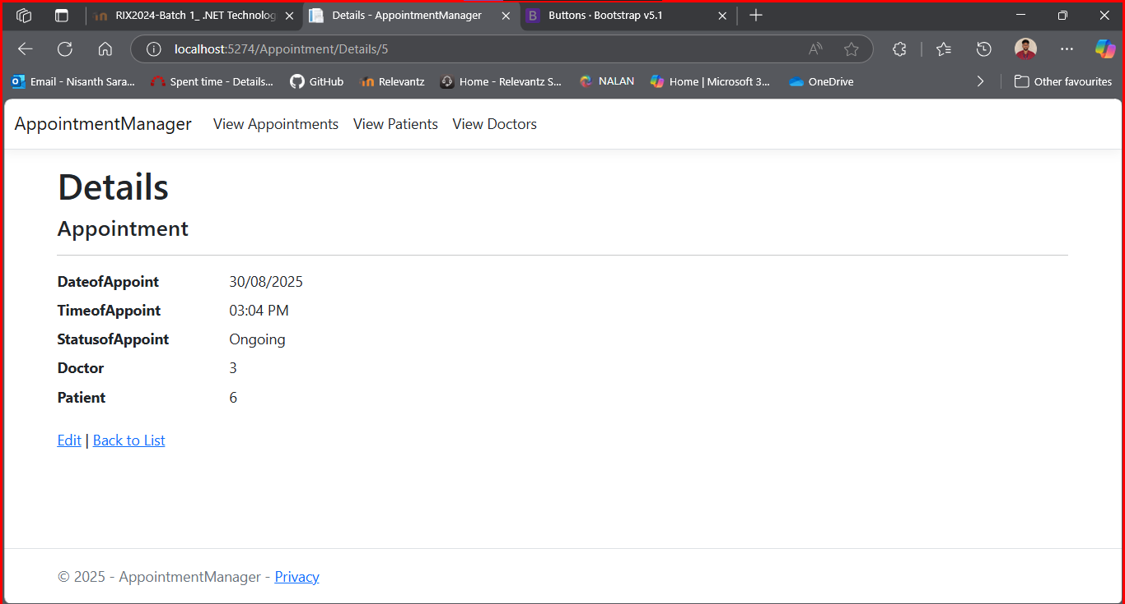
Edit

Before

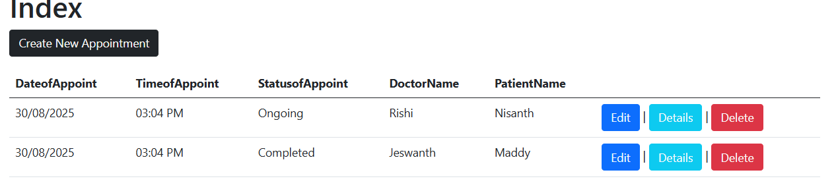

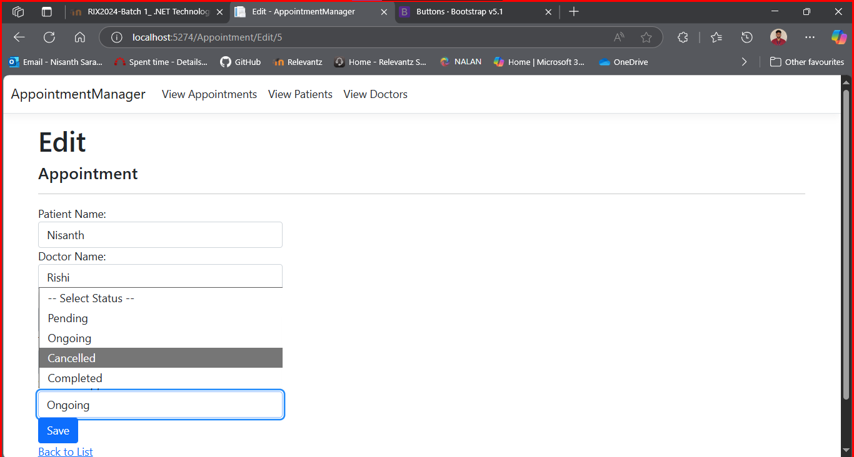

After

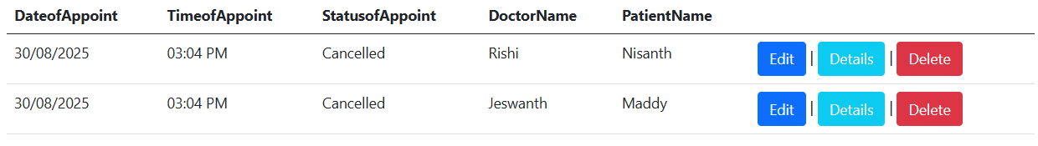
Delete

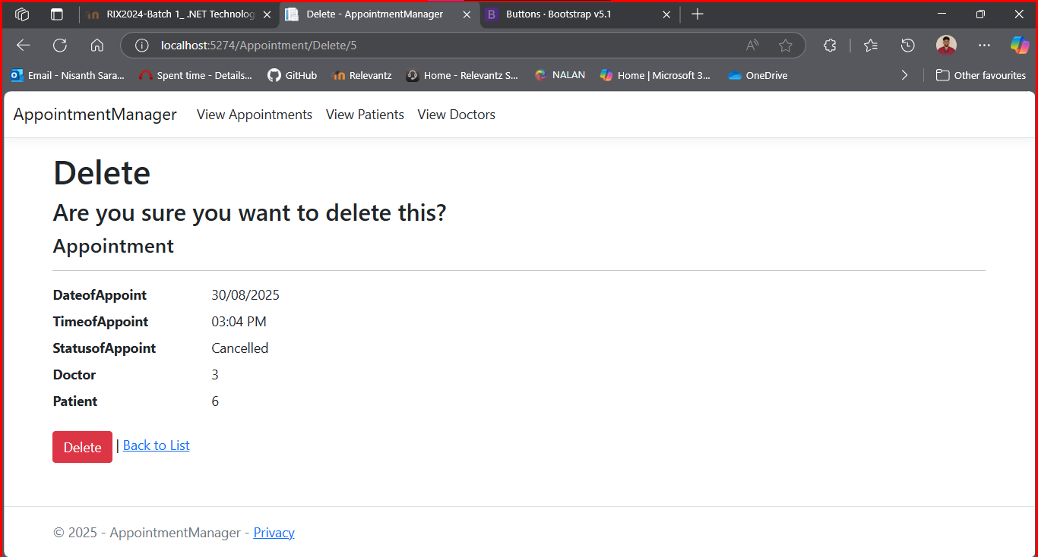

Post Deletion





